http://indobanged.blogspot.co.id/2015/06/kumpulan-ide-tulisan-erizeli-jely.html
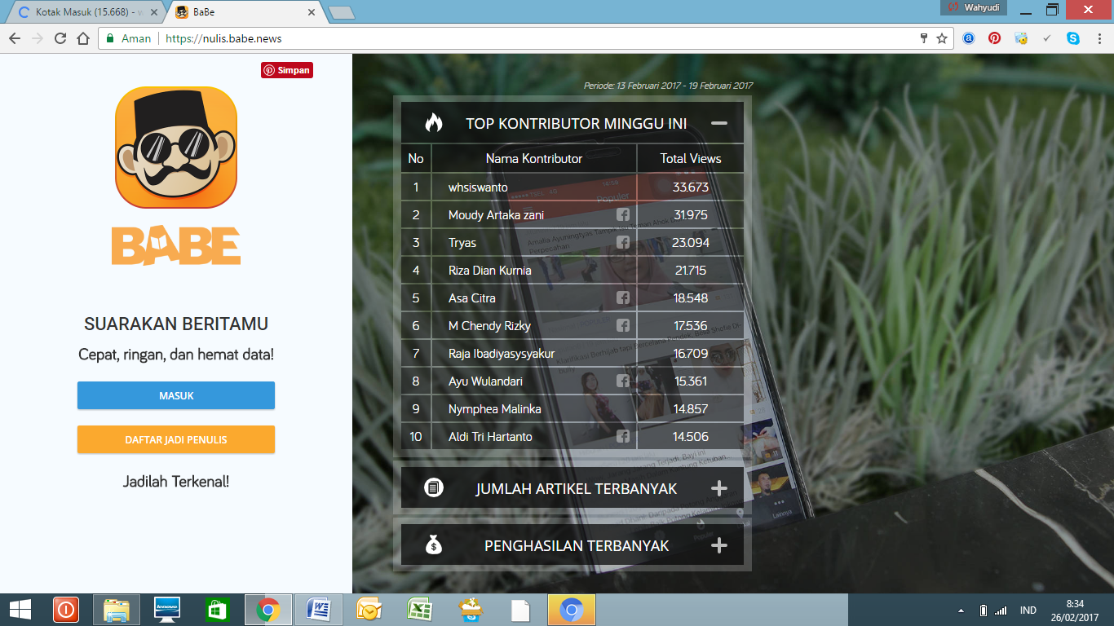
Akun: whsiswanto
I am Indonesian professional marketer, SEO, and content writer (www.whscorpora.co.id). As information, one of our specific skill is in creating business and financial articles/review, travel, engineering and others type of articles. I have many years experience in creating good business content articles. Several of my portfolios are:
Indonesia Media Online Content:
- www.cermati.com
- http://www.asura.co.id/
- https://www.klaritikita.com/blog/
- http://Aturduit.com
- http://imoney.co.id
- http://blog.cintasejati.co.id/
- http://www. hello-pet.com
- http://www.bolahero.com
- www.undercover.co.id
- www.intim.id
- https://seks.babe.news/
- https://kesehatan.babe.news/

English Content:
- http://www.program-plc.blogspot.com
- IT Start Up Project Indonesia- Japanese Business Plan from Shiho Honda
- Writers needed for writing Ebooks hired by Parham Jazaee, Founder and CEO Prince Publishing Partnership for Amazon Kindle Direct Publishing
- Research Assistant for opening gym and fitness business in Indonesia, Hired by Philippa Gebbie
- Looking for Indonesia social media marketing person Mike Wilson
- Jasmin Hagn (San Fransisco) - Market Research for Indonesia Economic Growth
- SEO for indonesian bahasa sites, elance.com by terence t. (doktersingapura.com)
- Contract with Indonesian Journalist Article Writer for Online Media - iMoney.my
Hired by Jason Kon
- Contract with www.cekindo.com hired by Michal in elance.com ((finance/business review)
- Writing blog posts about the manufacturing sector of some Asian countries hired by Renaud Anjoran (finance/business review)
- Asians (Indonesian) needed to write about their hometowns/cities/travel ((travel experience in Indonesia)
- Control System PLC SCADA implementation hired by Robert
Skype/mail: whsiswanto@gmail.com
HP/WA: 081392261062
www.whscorpora.co.id

