Mohammad Audrian Insya
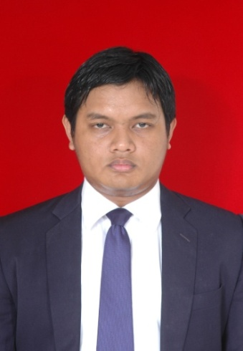
RESIDENCE ADDRESS
Jl. Rawamangun Utara II No. 28
Kelurahan Rawasari Kecamatan Cempaka Putih
Jakarta Pusat 10570

E-MAIL ADDRESS:
mohammad.audrian@yahoo.com
audri.simplyfied@gmail.com

MOBILE NUMBER:
085697927687

Personal Data
Date of Birth : December 3rd 1988
Place of Birth : Jakarta
Marital status : Married
Religion : Islam
Height : 175 cm
Weight : 85 kg
Linguistic Skill : Bahasa Indonesia (Reading, Speaking, Writing);
English (Reading, Speaking, Writing);
Japanese (Speaking)
Computer Skill : Microsoft Office (word, excel, power point, access), Internet
Objective : TO BECOME A PROMINENT LEGAL PROFESSIONAL

Working Experience
September 2011 – March 2015 Chandra Motik Yusuf and Associates (Associate Lawyer)
Note: Held PERADI Temporary License
Salary : IDR 5.000.000,00
Job Description:
- Conducting legal research and making legal opinion for Client’s Legal Issues;
- Support Clients in legal action either litigation or non-litigation.

Notable Projects
- Acting as the Defense Lawyer for the Master of KMP. Marina Nusantara for the criminal case of the vessel collision accident between KMP. Marina Nusantara and Tk. Pulau Tiga on Barito River Waters on February – August 2012, which case is registered in Banjarmasin District Court ;
- Acting as the Lawyer of the owner of KMP. Bahuga Jaya as the Plaintiff for the civil claim against the Master and the Owner of MV. Norgas Cathinka on the case of the sinking of KMP Bahuga Jaya after collided with the tanker MV. Norgas Cathinka on Sunda Strait Waters on December 2012 – June 2013, which case is registered in Serang District Court;
- Acting as the Lawyer of the owner of TB. Putra BES 005 as the Defendant on the civil claim by an Insurance company because of subrogation given by it’s insured party on the case of the capsize of Tk. Cipta Makmur I (towed by TB. Putra BES 005) on Karimun Jawa Islands Waters on January 2013 – August 2013, which case is registered in Jambi District Court;
- Acting as the Lawyer of PT. NEC Indonesia on the case of non-performing payment by one of it’s clients;
- Acting as the Lawyer of PT. Fracht Artha Global on the case of non-performing payment by one of it’s clients;
- Acting as the Lawyer of PT. First Wap to report a case of the Market Secret Theft to Indonesian Police Force Headquarters;
- Acting as the Lawyer of a foreign client to report a case of document falsification and embezzlement to the Indonesian Police Force Headquarters;
- Acting as the Lawyer of PT. Kembar Bangun Mandiri (the agent of Skydrol LD-4 lubricant) to report it’s principal to the Komisi Pengawas Persaingan Usaha (KPPU) because of unfair business competition;
- Acting as the Lawyer of Himpunan Nelayan Seluruh Indonesia (HNSI) Fishermen to claim for the loss because of the mass death of fish on Cilacap Waters caused by the oil leakage from the vessel owned by one of Indonesia State Owned Corporation;
- Drafting Business Agreement between PT. Global Gulf Resources Trading and CV. Mentari Kalimantan;
- Advising the Minister of Transportation of Republik Indonesia about the Cabotage Principle;
- Advising Telal Hatta General Trading (UAE Based trading company) about the setting up of a joint venture company in Indonesia;
- Advising Brittania P&I Club about arbitration proceedings in Indonesia;
- Advising PT. Djakarta Lloyd about the bareboat charter system;
- Advising PT. Evergreen Shipping Agency Indonesia about the Shipping Permitt;
- Advising PT. Orient Overseas Container Line Indonesia about the setting up of the Marine Transportation Company;
- Advising Lembaga Pengelola Dana Bergulir Koperasi Usaha Mikro Kecil dan Menengah (LPDB KUMKM) about “fiduciary assignment” and “inheritence as security for a loan”;
- Advising Sigur Ros Sdn. Bhd (Malaysia Based Company) about the Procedure to Reflag a Malaysian Flagged Vessel into an Indonesian Flagged Vessel;
- Advising PT. BW Offshore about putting a Vessel into mortgage for security;
- Advising PT. Pelabuhan Tiga Bersaudara about a “pilotage mandatory waters” area in Philips Strait near Batam Island.
- Advising PT. Patria Maritime Lines about the the “flag” status of it’s vessels as the company is a subsidiary of the joint venture public listed corporation.
- Etc.
Formal Education
2007 – 2011 Universitas Indonesia, Depok
Faculty of Law (Bachelor of Law/Sarjana Hukum)
2003 – 2006 SMAN 77, Jakarta
2000 – 2003 SMPN 216, Jakarta
1997 – 2000 SDN Kenari 07 Pagi, Jakarta
1994 – 1997 SD Muhammadiyah 8, Jakarta
Non Formal Education/Training & Seminars
2013 English for Lawyers (Imran Ganie & Partners Education of Law)
2011 Special Course for Advocate Profession (FHP Education of Law)

